**Chapter 2 suggested homework problems - solutions**

2.20 Note: you can also use the admittance (Y) form of the loads to do your calculations. In this case you would have S = |V|2Y. If using the impedance form (below), remember that you must conjugate the impedances before dividing!

$$S_{1}= \frac{{\left|V\right|}^{2}}{{Z_{1}}^{*}}= \frac{{100}^{2}}{20∠-30°}=500∠30° VA=433+j250 VA$$

$$S_{2}= \frac{{\left|V\right|}^{2}}{{Z_{2}}^{*}}= \frac{{100}^{2}}{25∠-60°}=400∠60° VA=200+j346.4 VA$$

$$S_{tot}=633+j596 VA$$

These power triangles are copied from the author’s solutions, so the numbers may be a little different than mine:

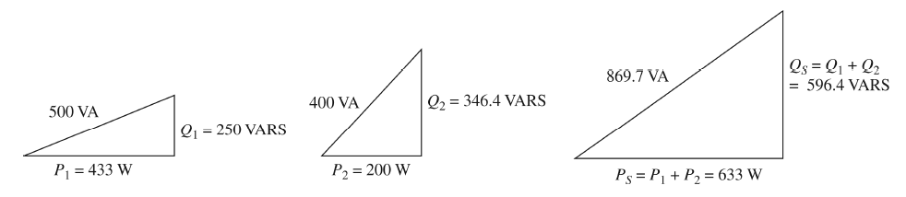

$$check: Z_{1}||Z_{2} = \frac{1}{{Z_{1}}^{-1}+{Z_{2}}^{-1}}= \frac{1}{0.0433-j0.025+0.02-j0.03464}=11.5∠43.29° Ω$$

$$S_{tot}= \frac{10,000}{11.5∠-43.29°}=869.6∠43.29°≅633+j596 VA$$

2.24

$$S_{1}=10+j0 kVA; S_{2}= \left(10k\right)\left\{\left(0.9\right)+j\sin\left[\cos^{-1}\left(0.9\right)\right]\right\}=9+j4.359 kVA$$

$$P_{in,3}= \frac{\left(10\right)\left(0.746\right)}{0.85}=8.776 kW; S_{3}=8.776-j\left(\frac{8.776}{0.95}\right)sin\left[\cos^{-1}\left(0.95\right)\right]=8.776-j2.885 kVA$$

$$S_{tot}= S_{1}{+ S}_{2}+ S_{3}=27.78+j1.474 kVA$$

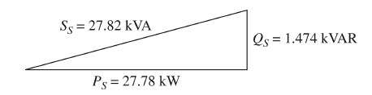

One of the most difficult quantities to obtain is reactive power, when given real power and power factor. There is a handy equation for this (used above):

$$Q= \left(\frac{P}{pf}\right)\sin\left[\cos^{-1}\left(pf\right)\right]; (positive if lagging pf and negative if leading pf)$$

Note that $\left(\frac{P}{pf}\right)$ is the “apparent power” |S| and cos-1(pf) is the power angle in degrees

2.27

Since we are given the load in terms of P and pf, we need to find Qold:

We can use the same formula to find the corrected value of Qnew, because P does not change:

$$Q_{new}= \left(\frac{50k}{0.95}\right)\sin\left[\cos^{-1}\left(0.95\right)\right]=16.43 kVAR$$

$$Q_{corr}=16.43-37.5= -21.07kVAR; C= \frac{\left|Q_{corr}\right|}{ωV^{2}}= \frac{21.07k}{\left(377\right){\left(220\right)}^{2}}=1.155 mF$$

2.30

By this time, you should be able to figure out how to combine the loads. Here is the total you get:

$$S_{tot}=60+j80 kVA=100∠53.13° kVA with pf=0.6 lagging$$

$$I_{tot}= {\left(\frac{100k∠53.13°}{1000}\right)}^{*}=100∠-53.13° A$$

$$Q_{new}= \left(\frac{60k}{0.8}\right)\sin\left[\cos^{-1}\left(0.8\right)\right]=45 kVAR$$

$$Q_{corr}=45-80= -35kVAR; C= \frac{\left|35k\right|}{ωV^{2}}= \frac{35k}{\left(377\right){\left(1000\right)}^{2}}=92.85uF$$

$$I_{new}= {\left(\frac{60+j45 kVA}{1000}\right)}^{*}=60-j45 A=75∠-36.87° A$$

Thus, we have corrected the system to where it is drawing 75A instead of 100A!

2.37

Note that a current source (IS1) in series with a resistor introduces a trivial row to the 4x4 system. Once everything is calculated, you should get approximately the following:

$$\left[\begin{matrix}1 & -1 & 0 & 0 \\ -1 & 2.083-j1 & -0.333+j1 & -0.25 \\ 0 & -0.333+j1 & 0.333-j0.25 & -j0.25 \\ 0 & -0.25 & -j0.25 & 0.25-j0.083\end{matrix}\right]\left[\begin{matrix}V_{1} \\ V_{2} \\ V_{3} \\ V_{4}\end{matrix}\right]= \left[\begin{matrix}1∠0° \\ 0 \\ 0 \\ 2∠30°\end{matrix}\right]$$

2.43

The second load is delta connected, so we need to change it to a wye equivalent by dividing by three:

$$Z_{2,wye}= \frac{60-j45}{3}=20-j15 Ω$$

The voltage source is line-to-line, so it needs to be divided by root 3. We can also arbitrarily reference the source voltage to 0° phase. Once this is done, we have the following single-phase equivalent circuit:

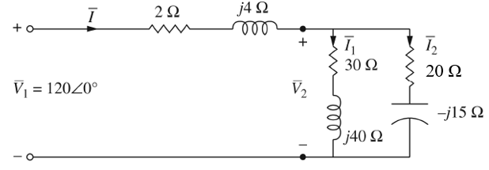

$$Z_{tot}=2+j4+\left(30+j40\right)||\left(20-j15 \right)=24 Ω$$

$$I= \frac{120}{24}=5∠0°A; S_{1ϕ}= \left(120\right)\left(5\right)=600 W$$

$$S_{3ϕ}=3\left(600\right)=1800 W$$

To find the voltage at the load, we need to calculate the voltage drop on the line:

$$V_{line}=5\left(2+j4\right)=10+j20; V_{2}=120-10-j20=110-j20 V=111.8∠-10.3° V$$

2.51 Here is one more good practice problem for 3-phase circuits.

The strategy here is:

* Find single phase equivalents of each load
* Find the load currents per phase
* Add up the current to find a single-phase line current
* Work backward to find the wye-equivalent voltage at the sending end
* Convert to a line voltage at the sending end

$$Load 1: S_{1,1ϕ}= \frac{150+j120 k}{3}=50+j40 kVA$$

$$Load 2: Z_{2,1ϕ}= \frac{150-j48}{3}=50-j16 Ω (Δ to wye)$$

$$Load 3: P= \left(0.6\right)\left(120k\right)=72 kW; Q= -\left(120k\right)\sin\left[\cos^{-1}\left(0.6\right)\right]=-96 kVAR$$

$$S_{3,1ϕ}= \frac{72-j96 k}{3}=24-j32 kVA$$

Now we can find each load current and the total current:

$$I_{1}= {\left(\frac{50+j40 k}{2000}\right)}^{*}=25-j20 A$$

$$I_{2}= \frac{2000}{50-j16}=36.29+j11.61 A$$

$$I_{3}= {\left(\frac{24-j32 k}{2000}\right)}^{*}=12+j16 A$$

$$I_{tot,1ϕ}=73.29+j7.61 A$$

This is the line current flowing in each phase.

$$Sending: V_{S,wye}=2000+ \left(73.29+j7.61\right)\left(0.2+j1\right)=2007.05+j74.81 V=2008.44∠2.13° V$$

$${\left|V\right|}_{line}= \sqrt{3}\left(2008.44\right)=3478.62 V$$